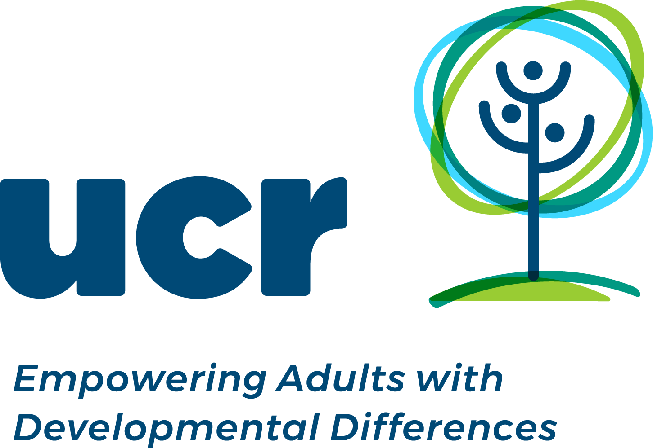
UCR 5K WALK & ROLL-A-THON & DANCE PARTY
SATURDAY, APRIL 27, 2024
4:00PM BOHRER PARK
Upcounty Community Resources, Inc. offers therapeutic, vocational, respite and social opportunities for the members of our community with developmental & intellectual differences. These opportunities promote healthy lifestyles, friendships, self-awareness, independence and personal-development for several hundred members, families & caregivers.
Sponsorship Levels
$2,000 | Angel | Electronic publicity, participant shirts, along the route signage, mention from stage, ongoing promotion
$1,000 | Champion | Electronic publicity, logo shirts, logo banner, mention from stage, signage along route
$500 | Partner | Electronic publicity, logo shirts & logo banner
$250 | Supporter | Electronic publicity & shirts
$150 | Friend | Listing on website

TAX ID# 46-1746790
www.ucresources.org
Gift cards and smaller donations also accepted.
Empowering Adults with Developmental Differences

